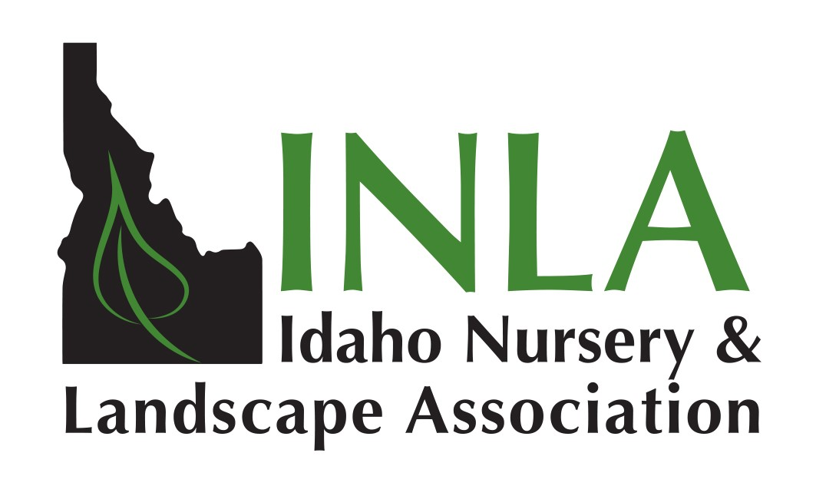
Let us help you
Promote Your Business!
www.inlagrow.org

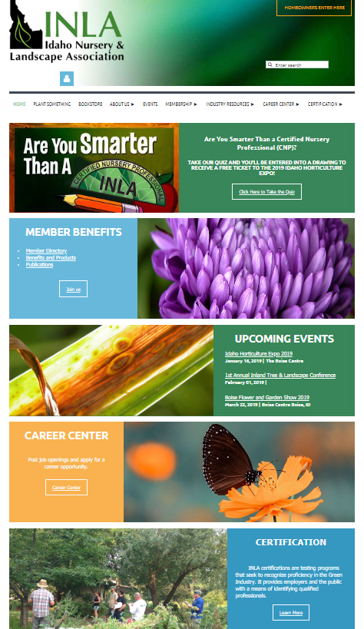
 Your Company listing on the INLA website
Membership includes a free listing on the INLA web page with your business’ name, telephone number and address; listings include all of your business’s classifications (i.e. retail, landscape contractor, grower, etc.) Do you have a website? There will be an automatic link from your business on the INLA website to your own website. Have you “liked” us on Facebook yet?

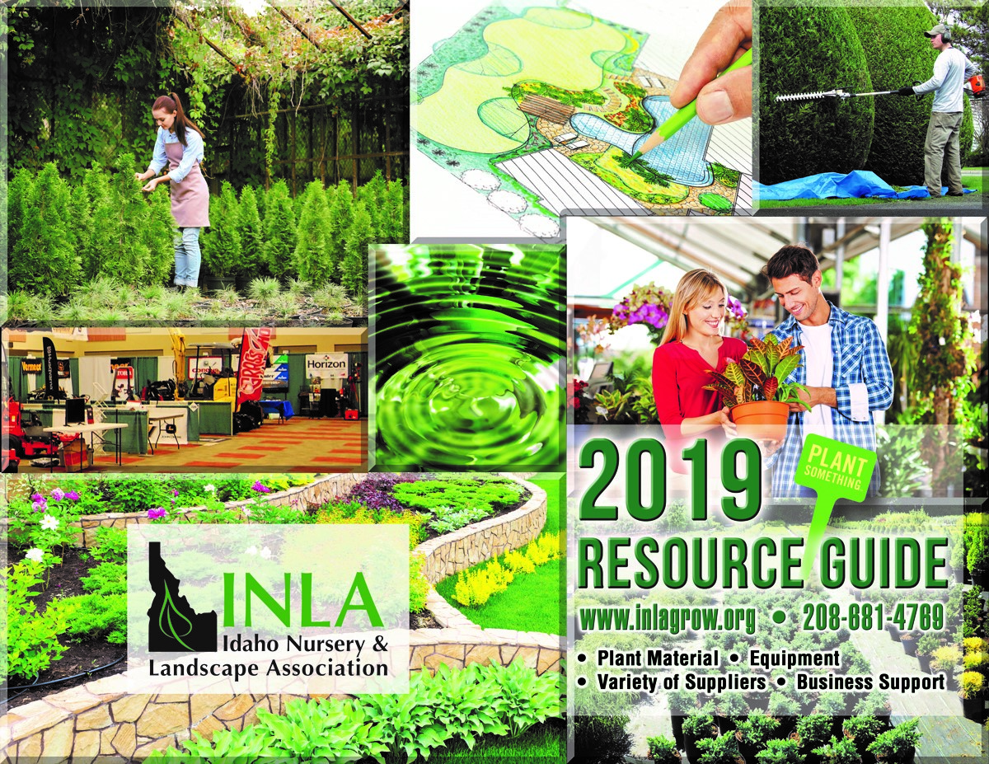
 Your Company listing in the Resource Guide
Selling plants wholesale? Or wholesale supplies? If so, as a member you will be listed in INLA’s Resource Guide at no charge. The list is dispersed at many trade shows in the west and distributed by mail or fax from the INLA office to potential buyers nationwide.

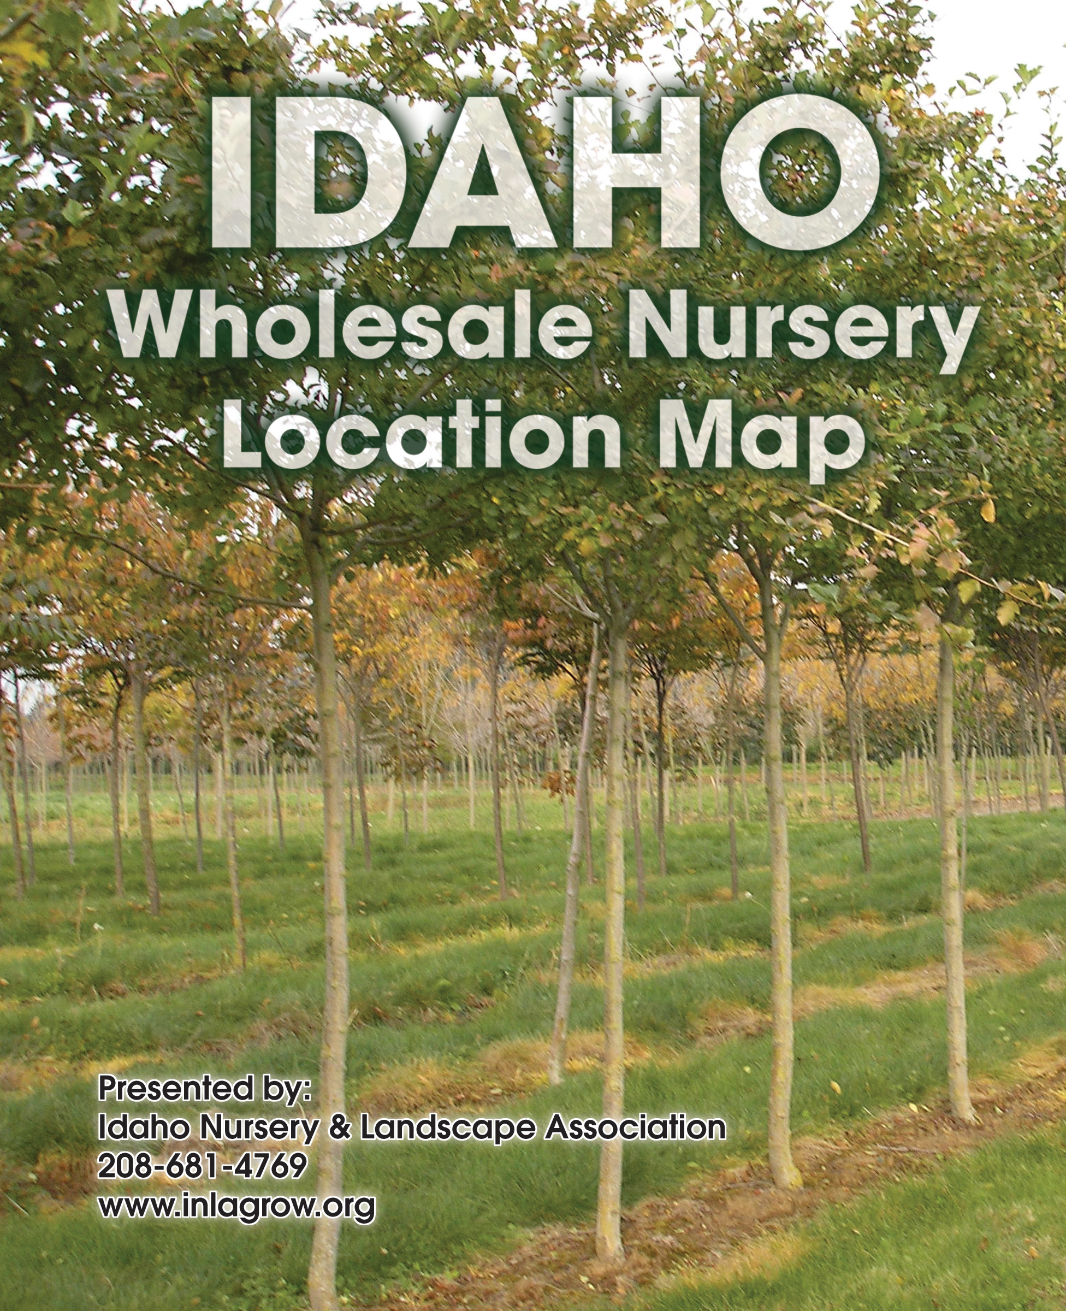
 Your Wholesale Nursery Locator Map Company listing
We have a map that we hand out at trade shows and mail to your potential customers showing the physical location to your business. Each member is listed with their address, phone, fax, email, website and directions to their establishment. Logos are included to identify your company.

 Your Company’s Credentials Promoted to the Public

All retail, landscape installation and/or maintenance, arborist and tree care businesses will benefit from the promotions that INLA makes on your behalf. At consumer shows INLA promotes the importance of hiring a professional to care for their yard and gardens. We encourage purchasing quality plant material from members. We provide publications that educate the consumer on invasive plants, proper planting and water efficiency. Consumers are also informed about the importance of certification credentials.
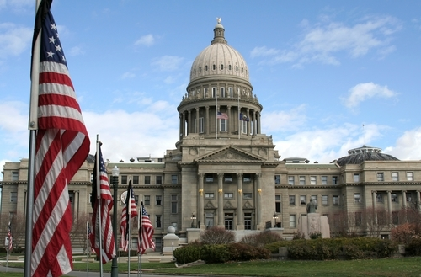
 Legislative Representation for You
The INLA coordinates grass roots lobbying efforts to help protect all segments of the green industry in Idaho. Speaking on behalf of our members, the INLA has the power to influence decisions being made in both the State and Federal legislature. INLA also serves as a conduit between governmental agencies, such as Idaho State Department of Agriculture and Idaho Department of Lands with industry.
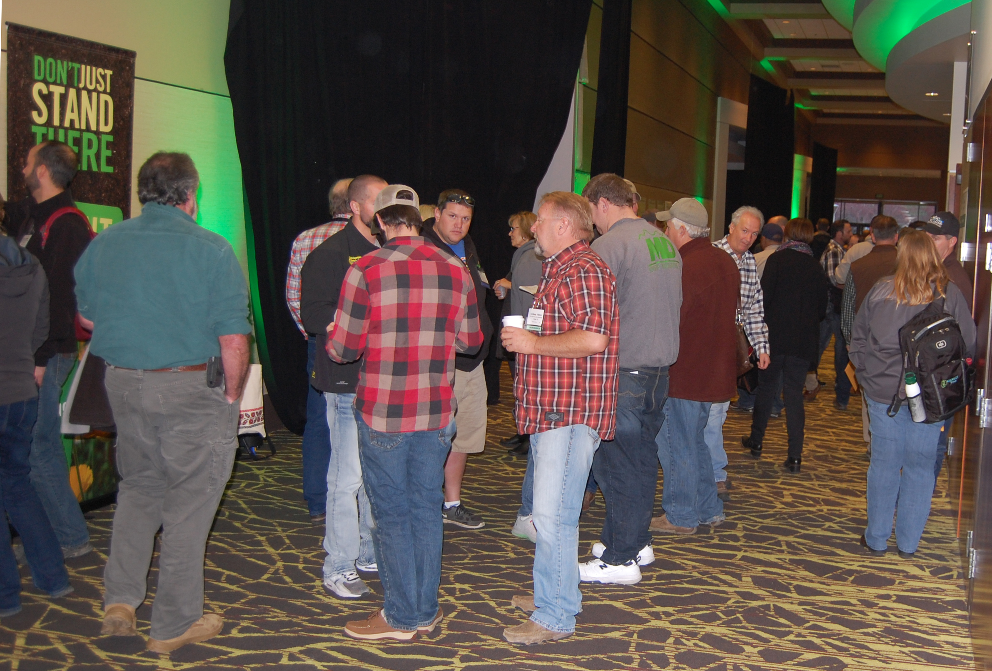
 Idaho Horticulture Expo
Each January the IHE is held in Boise. Nationally recognized experts are invited to address a wide range of topics covering all segments of the industry’s interests. A trade show featuring over 100 booths is held and features the newest in products and technology available. Members receive a discount on registration prices.

INLA offers these additional benefits to our members



