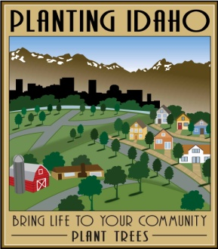
NEWS UPDATE
______________________________________________________________________________

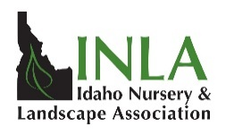
FOR IMMEDIATE RELEASE
Idaho Nursery and Landscape Association
CONTACT: Ann Bates, Executive Director
Phone: (208) 681-4769
Email: abates@inlagrow.org
Website: inlagrow.org

2019 Arbor Day Grants Offered to Idaho Communities in Partnership with Idaho Nursery and Landscape Association, Idaho Department of Lands, and Idaho Utilities.

(Idaho Falls…February 2019). The Idaho Nursery and Landscape Association (INLA), in cooperation with the Idaho Department of Lands (IDL), Avista, Rocky Mountain Power, and Idaho Power, is pleased to announce a program intended to help communities celebrate Arbor Day, plant appropriate trees for energy conservation and foster a stronger relationship between Idaho communities and the Green Industry. This year 45 Arbor Day grants will be awarded to Idaho communities in the amount of $300.00 each for “Planting Idaho”. Funding for this program is provided by the generous contribution of Idaho utilities that have a large interest in healthy urban forests and having the right tree planted in the right place.

This year grants of $300 each will be available for communities to purchase trees, shrubs and related materials for their Arbor Day celebration. For the 17th consecutive year, Avista, Idaho Power and Rocky Mountain Power, in partnership with IDL, have generously donated funds to support this program. The funds are a part of the Idaho Community Forestry Trust Account supported in part through the contributions of these utilities. All Idaho communities are encouraged to participate in the “Planting Idaho” program. Applications will be sent to communities throughout Idaho and a lottery style drawing will be used to determine who receives the grants.

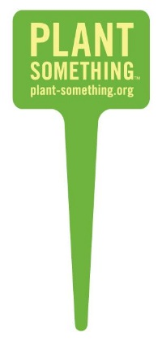
Information on the grant program has been mailed to communities in Idaho and is also available at the INLA web page: www.inlagrow.org (click on Planting Idaho). Application deadline is March 22, 2019. Successful grant applicants will be notified the week of March 25th.

Idaho joins most other states in celebrating Arbor Day on Friday, April 26, 2019. However, trees and planting conditions don’t honor calendars – your community may choose to celebrate Arbor Day on a different date. For further information, contact Ann Bates at (208) 681-4769.

